Jaipur Engineering College & Research Centre, Jaipur

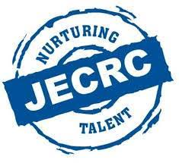

Teachers Day Celebration
Session (2017-18)

Teachers Day- 2017
In the honor of Birth Anniversary of second President of India, Dr. Sarvepalli Radhakrishnan, 5th Sept. is celebrated as Teacher’s Day since 1962. It creates a bond of faith between both the teachers and the students. The Teacher’s Day was also celebrated in the Mechanical Engineering Department of JECRC foundation. The students of 5th semester managed the event in a good manner. There was peace and pretty environment everywhere. All students welcome the teachers in a proper way. Welcome speech was delivered by Pankaj Maharashi in honor of the teachers. The event started by cutting of cake. HOD Sir of ME Department Dr. M.P. Singh was invited on the stage to share his experience on the event and to give the right direction for future of the students. They share their own experience of life to get succeed. Some more known personalities of department were also invited to deliver some thoughts, Mr. Kuldeep Sharma, Dr. Manish Shrivastva, Mr. Lalit Kumar Sharma, Mr. Yogesh Dubey,
Mr. Abhishek Kumar, Mr. Manmohan Siddh and many more teachers shared their experiences with the students and give them the right path of success.
The whole event was very exciting and the event was ended with some refreshment to faculty
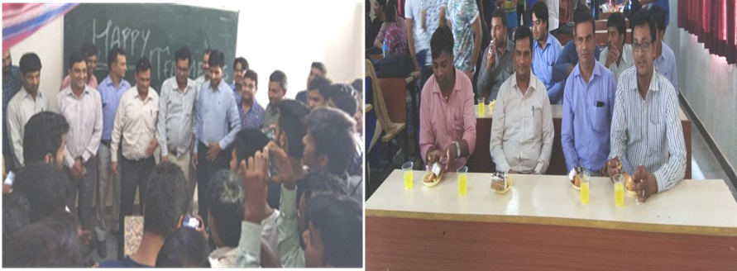
members and staff.

