Jaipur Engineering College & Research Centre, Jaipur

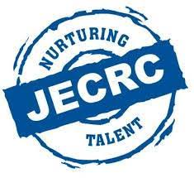

Teachers Day Celebration
Session (2020-21)

Teachers Day 2020
Though COVID-19 has stopped the whole world but the Education, love & Respect finds their way. This year Mechanical students prepared a grand online celebration for teachers glimpses of which are attached.

